*Figures and Tables*

MeshMonk: open-source large-scale intensive 3D phenotyping

Julie D. White1*, Alejandra Ortega-Castrillón2,3, Harold Matthews4,5,6, Arslan A. Zaidi1,7, Omid Ekrami8, Jonatan Snyders9, Yi Fan4,10, Tony Penington4,5,6, Stefan Van Dongen8, Mark D. Shriver1, Peter Claes2,3,4*

**\* Correspondence:**jdw345@psu.edu; peter.claes@kuleuven.be

**Figures**



**Figure 1. Schematic of the MeshMonk’s surface registration algorithm.** MeshMonk uses an initial rigid registration based on the ICP algorithm. This step might require an initial rough alignment to ensure similar orientation, which can be done by placing few landmarks on the target surface. Then, the symmetrical weighted k-neighbor correspondences are found, and outliers are detected and removed. Finally, the visco-elastic transformation is applied. This is performed in an iterative manner, until either a pre-set number of iterations or a pre-set amount of coverage (e.g. a pre-defined root mean squared distance of all template points to the target surface after the transformation) has been reached. Otherwise, the correspondences are updated and the non-rigid registration starts over.



**Figure 2. Depiction of MeshMonk registration process.** **(A)** The target and template are separated and not necessarily aligned in space or scale. **(B)** The template is scaled to fit the target and is matched with the target using a rigid registration step. **(C)** The template is further modified to fit the target using a non-rigid registration step that allows for fine adjustment.



**Figure 3. Manual validation landmarks.** Seven midline and twelve bilateral landmarks indicated by two observers during validation of the MeshMonk software.Descriptions of the landmarks are present in SI Table 2.



**Figure 4. Depiction of automatic landmark indication. (A)** Each facial scan was manually landmarked six times, three times each by two observers (red and blue points). **(B)** These iterations were then averaged together and are placed on the template (purple points). **(C)** The average of all but the test face (N=40) placements on the template, serving as the foundation for the automatic landmark placements (magenta points). **(D)** Coordinate conversions, described in more detail in the Supplemental Methods, is used to subsequently transfer the automatic landmark placements from the template to the target (left-out) surface, serving as the automatic landmark indication for the target surface (magenta points). **(E)** The manual landmark indications from two observers (red and blue points) for the shown example face, for comparison to the automatic indication in (D).



**Figure 5. Bland-Altman plot for similarity between manual and automatic landmark placements.** For *x*, *y*, and *z* coordinates, Bland-Altman plot showing the differences between the manual (CML) and automatic (CAuto) landmark indications against the averages of the two techniques. Blue lines represent the mean difference value and red lines represent the upper and lower 95% confidence limits. Also given are the intra-class correlation coefficient with ICC 95% confidence interval.



**Figure 6. Comparison of centroid sizes.** (A) Point plots for comparison of centroid sizes using automatic and manual landmarking methods, separated by observer. (B) Bland-Altman plot showing the differences between centroid sizes produced using the manual and automatic methods against the averages of the two techniques. Blue lines represent the mean difference value and red lines represent the upper and lower 95% confidence limits.



**Figure 7. Comparison of inter-observer errors.** Standard deviation values calculated using both manual landmarks and after replacing each observer’s set iteratively with their automatic landmarks. All but the labiale superius landmark had significantly smaller variances in the automatic landmark indication comparison (AAuto vs. BAuto).

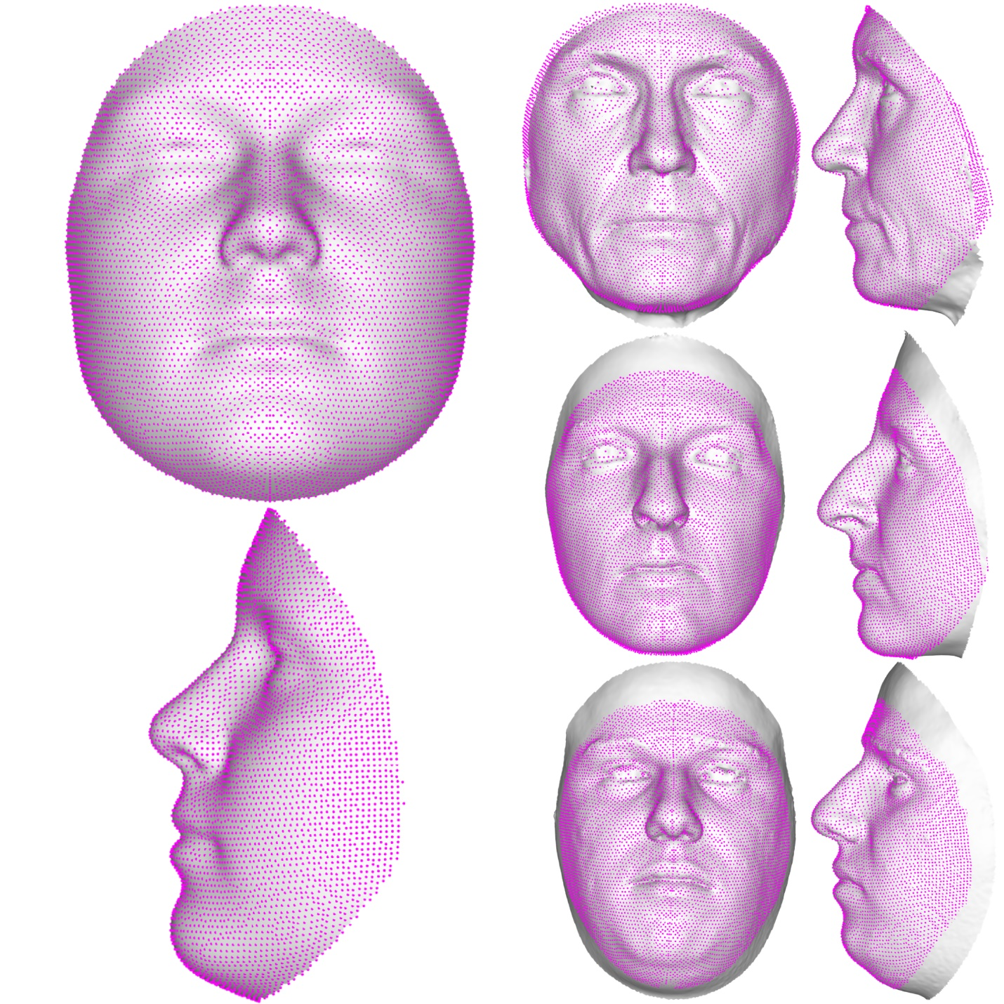

**Figure 8. Facial template registration.** The template (left), built as the average of more than 8000 admixed facial scans, can easily wrap onto any face (three example faces on the right), accurately representing its particular traits. This allows for the explanation of any face in the template’s coordinates, enabling a spatially-dense analysis between any registered surfaces.

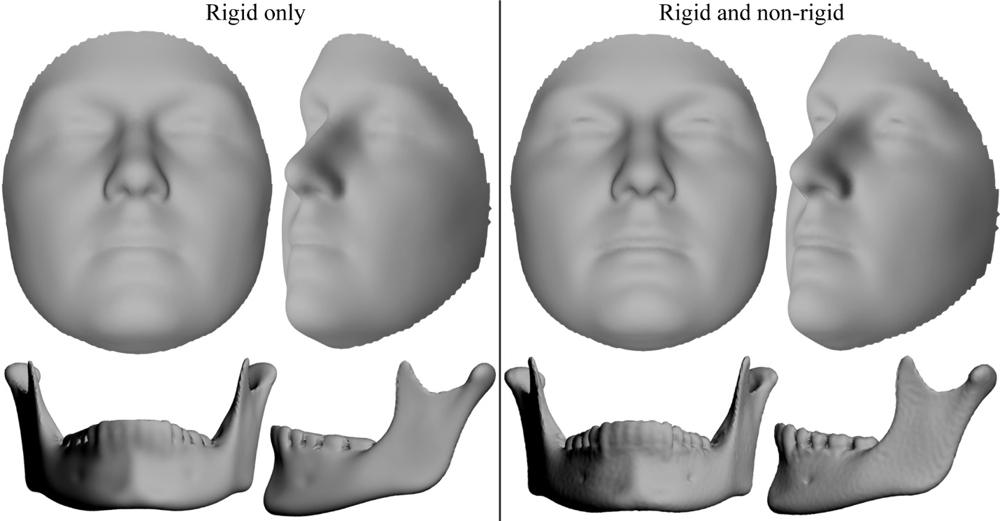

**Figure 9. Comparison of rigid and non-rigid registration algorithms.** Sample averages using the 41 validation faces and 100 mandible scans. Scans were registered using rigid registration only (left) and then simply mapped exactly to their closest point on the target surfaces or mapped using rigid plus non-rigid (visco-elastic) registration (right).

**2 Tables**

**Table 1. Root mean squared error between manual and automatic landmarks**. Root mean squared error (mm) between the manual and automatic landmark indications. Values are presented for each axis, averaged across all faces, as well as averaged across the axes (mean).

|  |  |  |  |  |  |  |  |  |  |  |  |  |
| --- | --- | --- | --- | --- | --- | --- | --- | --- | --- | --- | --- | --- |
| *Landmark* | *AML vs. AAuto* | | | | *BML vs. BAuto* | | | | *CML vs. CAuto* | | | |
| *X* | *Y* | *Z* | *Mean* | *X* | *Y* | *Z* | *Mean* | *X* | *Y* | *Z* | *Mean* |
| *Alar curvature left* | 0.17 | 0.54 | 0.59 | **0.44** | 0.19 | 0.65 | 0.76 | **0.53** | 0.16 | 0.52 | 0.61 | **0.43** |
| *Alar curvature right* | 0.18 | 0.53 | 0.67 | **0.46** | 0.18 | 0.58 | 0.61 | **0.46** | 0.17 | 0.52 | 0.57 | **0.42** |
| *Chelion left* | 1.23 | 0.70 | 0.64 | **0.86** | 1.26 | 0.74 | 0.66 | **0.88** | 1.11 | 0.71 | 0.61 | **0.81** |
| *Chelion right* | 0.93 | 0.70 | 0.53 | **0.72** | 1.15 | 0.65 | 0.62 | **0.81** | 0.98 | 0.66 | 0.55 | **0.73** |
| *Crista philtri left* | 0.69 | 0.85 | 0.44 | **0.66** | 0.89 | 1.01 | 0.51 | **0.80** | 0.75 | 0.89 | 0.45 | **0.70** |
| *Crista philtri right* | 0.66 | 0.95 | 0.50 | **0.70** | 1.00 | 1.13 | 0.47 | **0.87** | 0.76 | 1.00 | 0.44 | **0.73** |
| *Endocanthion left* | 0.84 | 0.64 | 0.53 | **0.67** | 0.83 | 0.62 | 0.42 | **0.62** | 0.78 | 0.54 | 0.40 | **0.57** |
| *Endocanthion right* | 1.05 | 0.74 | 0.62 | **0.80** | 1.09 | 0.62 | 0.45 | **0.72** | 1.04 | 0.65 | 0.50 | **0.73** |
| *Exocanthion left* | 0.92 | 0.78 | 0.91 | **0.87** | 0.97 | 0.75 | 0.88 | **0.87** | 0.91 | 0.74 | 0.88 | **0.84** |
| *Exocanthion right* | 0.93 | 0.67 | 0.93 | **0.85** | 0.98 | 0.68 | 0.97 | **0.88** | 0.94 | 0.65 | 0.95 | **0.85** |
| *Glabella* | 0.52 | 1.43 | 0.60 | **0.85** | 0.55 | 1.46 | 0.59 | **0.87** | 0.48 | 1.31 | 0.56 | **0.78** |
| *Labiale inferius* | 0.52 | 0.75 | 0.56 | **0.61** | 0.50 | 0.71 | 0.38 | **0.53** | 0.46 | 0.72 | 0.48 | **0.55** |
| *Labiale superius* | 0.57 | 0.72 | 0.31 | **0.54** | 0.59 | 0.98 | 0.37 | **0.65** | 0.59 | 0.81 | 0.33 | **0.58** |
| *Nasion* | 0.37 | 1.10 | 0.51 | **0.66** | 0.42 | 1.04 | 0.48 | **0.65** | 0.35 | 0.97 | 0.47 | **0.60** |
| *Pogonion* | 0.48 | 1.08 | 0.45 | **0.67** | 0.54 | 1.12 | 0.42 | **0.69** | 0.43 | 1.00 | 0.38 | **0.60** |
| *Pronasale* | 0.44 | 0.71 | 0.33 | **0.49** | 0.45 | 0.57 | 0.28 | **0.44** | 0.40 | 0.56 | 0.28 | **0.41** |
| *Subalare left* | 0.78 | 0.47 | 0.54 | **0.60** | 0.79 | 0.44 | 0.64 | **0.62** | 0.73 | 0.43 | 0.56 | **0.57** |
| *Subalare right* | 0.75 | 0.46 | 0.76 | **0.66** | 0.67 | 0.50 | 0.52 | **0.56** | 0.65 | 0.43 | 0.60 | **0.56** |
| *Subnasale* | 0.33 | 0.46 | 0.33 | **0.37** | 0.35 | 0.68 | 0.33 | **0.46** | 0.32 | 0.48 | 0.26 | **0.35** |
| *Mean* | **0.65** | **0.75** | **0.57** | **0.66** | **0.71** | **0.79** | **0.55** | **0.68** | **0.63** | **0.72** | **0.52** | **0.62** |

**Table 2. ANOVA of centroid sizes.** Results from an ANOVA with centroid size as the response variable and individual, observer, method and individual x observer as predictors.

|  |  |  |  |  |  |
| --- | --- | --- | --- | --- | --- |
| Variable | Df | Sum Sq | Mean Sq | F value | Pr(>F) |
| Individual | 40 | 7936 | 198.39 | 130.407 | <2 x 10-16 |
| Observer | 2 | 0 | 0.23 | 0.154 | 0.857 |
| Method | 1 | 0 | 0 | 0.002 | 0.962 |
| Individual x Observer | 80 | 12 | 0.15 | 0.101 | 1.000 |
| Residuals | 122 | 186 | 1.52 |  |  |

**Table 3. MANOVAs on average manual landmark configurations and automatic landmark configurations, separately.** Results of two separate MANOVAs, one using the average manual landmark configurations from each observer as the response, and the other using the automatic landmark configurations as the response. In both cases, individual and observer were included as predictors. The interaction effect between individual and observer was not included because the residual degrees of freedom became zero when it was included.

|  |  |  |  |  |  |  |  |  |
| --- | --- | --- | --- | --- | --- | --- | --- | --- |
| Variable | | DF | SS | MS | R2 | F | Z | Pr(>F) |
| Individual | *ML* | 40 | 0.3937 | 0.0098 | 0.9413 | 23.987 | 22.515 | 0.001 |
| *Auto* | 40 | 0.3152 | 0.0079 | 0.9714 | 435.70 | 27.609 | 0.001 |
| Observer | *ML* | 1 | 0.0082 | 0.0081 | 0.0195 | 19.853 | 11.563 | 0.001 |
| *Auto* | 1 | 0.0085 | 0.0085 | 0.0264 | 472.98 | 8.1969 | 0.001 |
| Residuals | *ML* | 40 | 0.0164 | 0.0004 | 0.0392 |  |  |  |
| *Auto* | 40 | 0.0007 | 1.81 x 10-5 | 0.0022 |  |  |  |
| Total | *ML* | 81 | 0.4182 |  |  |  |  |  |
| *Auto* | 81 | 0.3245 |  |  |  |  |  |

**Table 4. MANOVA on manual and automatic landmarks, together.** Results from a single MANOVA using the average manual landmark indications from each observer (AML and BML) and the automatic landmark indications using the observer level averages (AAuto and BAuto).

|  |  |  |  |  |  |  |  |
| --- | --- | --- | --- | --- | --- | --- | --- |
| Variable | DF | SS | MS | R2 | F | Z | Pr(>F) |
| Method | 1 | 0.0003 | 0.0003 | 0.0004 | 0.3463 | -2.2135 | 0.987 |
| Individual | 40 | 0.6522 | 0.0163 | 0.8778 | 20.2019 | 23.3507 | 0.001 |
| Observer | 1 | 0.0167 | 0.0167 | 0.0224 | 20.6396 | 11.4067 | 0.001 |
| Individual x Observer | 40 | 0.0085 | 0.0002 | 0.0114 | 0.2623 | 13.7253 | 0.001 |
| Residuals | 81 | 0.0654 | 0.0008 | 0.0880 |  |  |  |
| Total | 163 | 0.7430 |  |  |  |  |  |

**Table 5. Comparison of inter-observer errors.** Standard deviation for only manual landmarks and for manual and automatic comparisons. Based on a paired T-test, comparisons that are significantly different using an alpha of 0.05 are in bold.

|  |  |  |  |  |  |  |  |
| --- | --- | --- | --- | --- | --- | --- | --- |
|  | *AML-BML* | *AML – BAuto* | | | *AAuto - BML* | | |
| *Landmark* | *Mean SD (mm)* | *Mean SD (mm)* | *T*  *statistic* | *P value* | *Mean SD (mm)* | *T statistic* | *P value* |
| *Alar curvature left* | 0.31 | 0.31 | -0.10 | 0.9197 | 0.37 | -2.14 | **0.0382** |
| *Alar curvature right* | 0.33 | 0.37 | -0.99 | 0.3275 | 0.37 | -1.23 | 0.2266 |
| *Chelion left* | 0.42 | 0.63 | -1.89 | 0.0665 | 0.64 | -2.40 | **0.0212** |
| *Chelion right* | 0.30 | 0.51 | -2.59 | **0.0132** | 0.56 | -3.78 | **5.20 x 10-4** |
| *Crista philtri left* | 0.39 | 0.60 | -2.87 | **0.0066** | 0.59 | -3.11 | **0.0034** |
| *Crista philtri right* | 0.47 | 0.62 | -1.89 | 0.0661 | 0.67 | -3.53 | **0.0010** |
| *Endocanthion left* | 0.44 | 0.55 | -2.50 | **0.0167** | 0.52 | -1.46 | 0.1527 |
| *Endocanthion right* | 0.36 | 0.64 | -5.49 | **2.50 x 10-6** | 0.51 | -2.84 | **0.0071** |
| *Exocanthion left* | 0.29 | 0.62 | -6.14 | **3.00 x 10-7** | 0.61 | -5.80 | **8.93 x 10-7** |
| *Exocanthion right* | 0.29 | 0.60 | -5.54 | **2.09 x 10-6** | 0.62 | -5.65 | **1.49 x 10-6** |
| *Glabella* | 0.45 | 0.64 | -2.63 | **0.0121** | 0.66 | -3.12 | **0.0033** |
| *Labiale inferius* | 0.59 | 0.69 | -2.14 | **0.0381** | 0.62 | -0.54 | 0.5895 |
| *Labiale superius* | 0.32 | 0.50 | -3.05 | **0.0040** | 0.49 | -3.21 | **0.0026** |
| *Nasion* | 0.49 | 0.55 | -0.93 | 0.3556 | 0.57 | -1.25 | 0.2188 |
| *Pogonion* | 0.60 | 0.59 | 0.15 | 0.8835 | 0.61 | -0.22 | 0.8245 |
| *Pronasale* | 0.33 | 0.41 | -2.16 | **0.0366** | 0.36 | -0.65 | 0.5169 |
| *Subalare left* | 0.40 | 0.48 | -1.35 | 0.1842 | 0.51 | -2.24 | **0.0308** |
| *Subalare right* | 0.43 | 0.52 | -1.63 | 0.1114 | 0.47 | -0.84 | 0.4083 |
| *Subnasale* | 0.35 | 0.32 | 0.69 | 0.4939 | 0.36 | -0.26 | 0.7930 |
| *Mean* | 0.40 | 0.53 |  |  | 0.53 |  |  |

**Table 6. Comparison of error variance.** The standard deviation of average landmark configurations for the manual (AML vs. BML) and automatic (AAuto vs. BAuto) landmarks, averaged across scans. Levene’s test was performed per landmark to assess the difference between error variance.

|  |  |  |  |  |
| --- | --- | --- | --- | --- |
| *Landmark* | *Manual (mm)* | *Auto (mm)* | *F value* | *P value* |
| *Alar curvature left* | 0.3067 | 0.0728 | 59.6244 | **2.83 x 10-11** |
| *Alar curvature right* | 0.3287 | 0.2133 | 22.2346 | **1.01 x 10-5** |
| *Chelion left* | 0.4182 | 0.1998 | 4.6453 | **0.0341** |
| *Chelion right* | 0.2984 | 0.0637 | 24.5101 | **4.03 x 10-6** |
| *Crista philtri left* | 0.3881 | 0.3811 | 29.1832 | **6.60 x 10-7** |
| *Crista philtri right* | 0.4737 | 0.4472 | 18.1685 | **5.49 x 10-5** |
| *Endocanthion left* | 0.4362 | 0.3504 | 14.2000 | **3.13 x 10-4** |
| *Endocanthion right* | 0.3608 | 0.2669 | 28.4103 | **8.85 x 10-7** |
| *Exocanthion left* | 0.2946 | 0.0808 | 47.7334 | **1.06 x 10-9** |
| *Exocanthion right* | 0.2855 | 0.0961 | 28.0100 | **1.03 x 10-6** |
| *Glabella* | 0.4542 | 0.2938 | 41.5866 | **7.95 x 10-9** |
| *Labiale inferius* | 0.5857 | 0.5773 | 26.3847 | **1.93 x 10-6** |
| *Labiale superius* | 0.3185 | 0.3289 | 2.4213 | 0.1236 |
| *Nasion* | 0.4938 | 0.3511 | 87.7550 | **1.67 x 10-14** |
| *Pogonion* | 0.5987 | 0.3478 | 23.9927 | **4.95 x 10-6** |
| *Pronasale* | 0.3323 | 0.2376 | 38.2428 | **2.49 x 10-8** |
| *Subalare left* | 0.4005 | 0.3239 | 16.4805 | **1.14 x 10-4** |
| *Subalare right* | 0.4283 | 0.3113 | 25.6819 | **2.54 x 10-6** |
| *Subnasale* | 0.3480 | 0.2072 | 42.6476 | **5.57 x 10-9** |
| *Mean* | 0.3974 | 0.2711 |  |  |